Official league roster – Soccer 2022
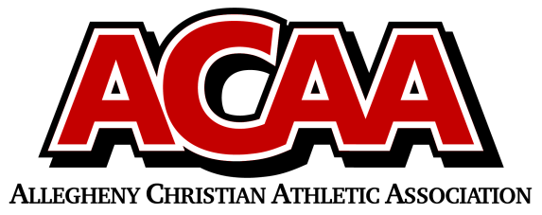
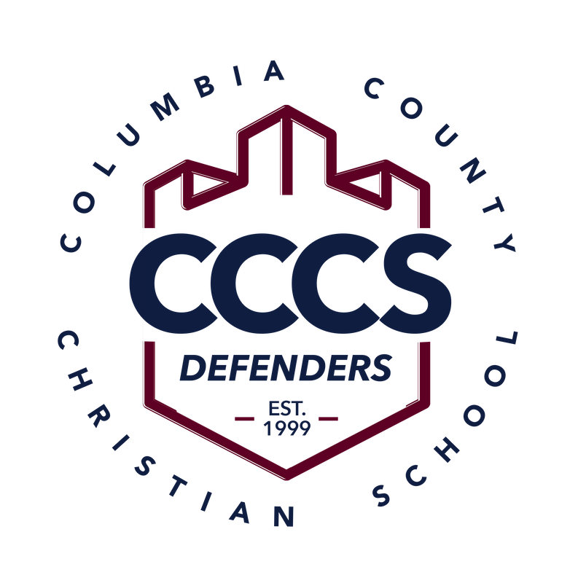

School Name: Columbia County Christian School
Team Colors: Navy Blue and Maroon
Overall Wins ___ Losses ____ Ties ___
ACAA Wins ___ Losses ____ Ties ___ OPPONENT: __________________________
Date: _________
Number | Name | Year | Position | Homeschool
11 | Lane Kindig | 12 | Mid/Def | yes
5 | Emmit Boucher | 12 | Mid | yes
6 | Conner Davis | 12 | Forward
00 | Luke Cughan | 12 | Goalie
7 | Elijah Beishline | 11 | Defender
10 | Chandler Davis | 11 | Forward
99/21 | Christopher Domenico | 11 | Goalie
3 | Clay Farley | 11 | Defender
15 | Hunter Fritz | 11 | Mid
12 | Jaksen Kline | 11 | Defender
13 | Moxley Runkle | 11 | Mid/Goalie
14 | Luke Moskovich | 9 | Mid/Forward
2 | Lyman Runkle | 9 | Forward
16 | Colton Snyder | 9 | Forward
8 | David Speaks | 8 | Mid/Forward
17 | Noah DiLena | 7 | Mid/Forward
18 | Brett Dombrosky | 7 | Forward
4 | Jentezin Runkle | 7 | Mid
10 | Landon Lahr | 7

Head Coach: James Boucher
Asst. coach: Bryant Yocum

Official ACAA League Team Roster. to be submitted to the scorer’s table before each game.

